Eventi
Use Case Specification

Submitted to:

Asst. Prof. Ma. Rowena C. Solamo
Faculty Member
Department of Computer Science
College of Engineering
University of the Philippines, Diliman

Submitted by:
Dimaano, Aaron Diego I.
Lopez, Matthew S.
Torres, Jacob Angelo V.

In partial fulfillment of academic requirements
for the course
CS 191 Software Engineering I
of the
1st Semester, AY 2015-2016
Unique Reference:
The documents are stored in https://github.com/Tom-2013-06417/CS191-192_Event_Sharing/tree/master/02-Requirements%20Engineering.
Link to this document:

Document Purpose:
The purpose of this document is to exhaust the step-by-step process of the Use Cases in every scenario possible. In this case, this document’s purpose is to show how the Registered Users would see a nutshell of statistics involving the flow of data, traffic, and event highlights.

Target Audience:
To our project client and adviser, our fellow 191 classmates, and our future selves when they need to refer back to this document.

Revision Control:

Revision Date | Person Responsible | Version  Number | Modification
09/18/15 | Dimaano, Diego  Lopez, Matthew  Torres, Jacob | 1.0 | Initial Document

Use-Case Name: View statistics

Description: A feature which allows you to see how well your events have been doing. This functionality aims to provide you with statistical data which you can use to improve your future events. This is also great for people who need to quantify the objectives for their events.

Preconditions: There is an internet connection to the Eventi server and a device with browsing capabilities.

Flow of Events:

Scenario Name | Description
Scenario 1 (Basic Flow)  Applicant is assigned to the training squad. | 1. Selection committee gets application form.  2. Club staff prepares try-out area.  3. Selection committee evaluates applicant's performance in mock try-outs.  4. If applicant needs training, he is assigned to the training squad.  5. Club staff keeps the application forms in the appropriate files.
Scenario 2  Applicant is assigned to the competing squad. | 1. Selection committee gets application form.  2. Club staff prepares try-out area.  3. Selection committee evaluates applicant's performance in mock try-outs.  4. If applicant plays excellent, he is assigned to the competing squad.  5. Club staff keeps the application forms in the appropriate files.

Activity Diagram of the Flow of Events:

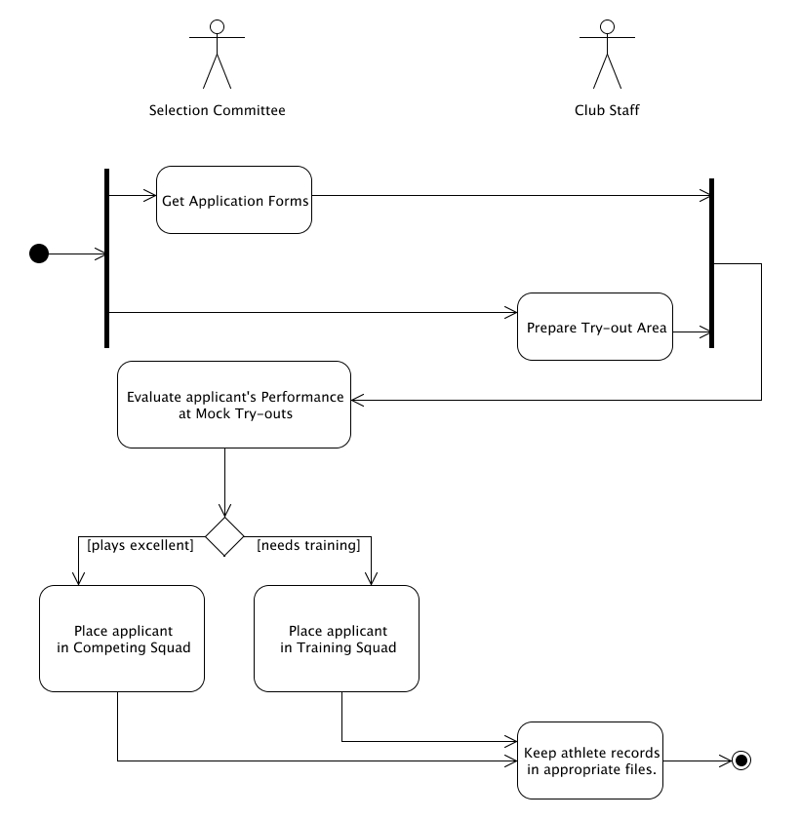

Post-conditions: Successful: The Eventi homepage has successfully loaded and the events are shown.
Failed: The website did not load.

Special Requirements: NONE

